Spring Core – Load Country from Spring Configuration XML

SCREENSHOT
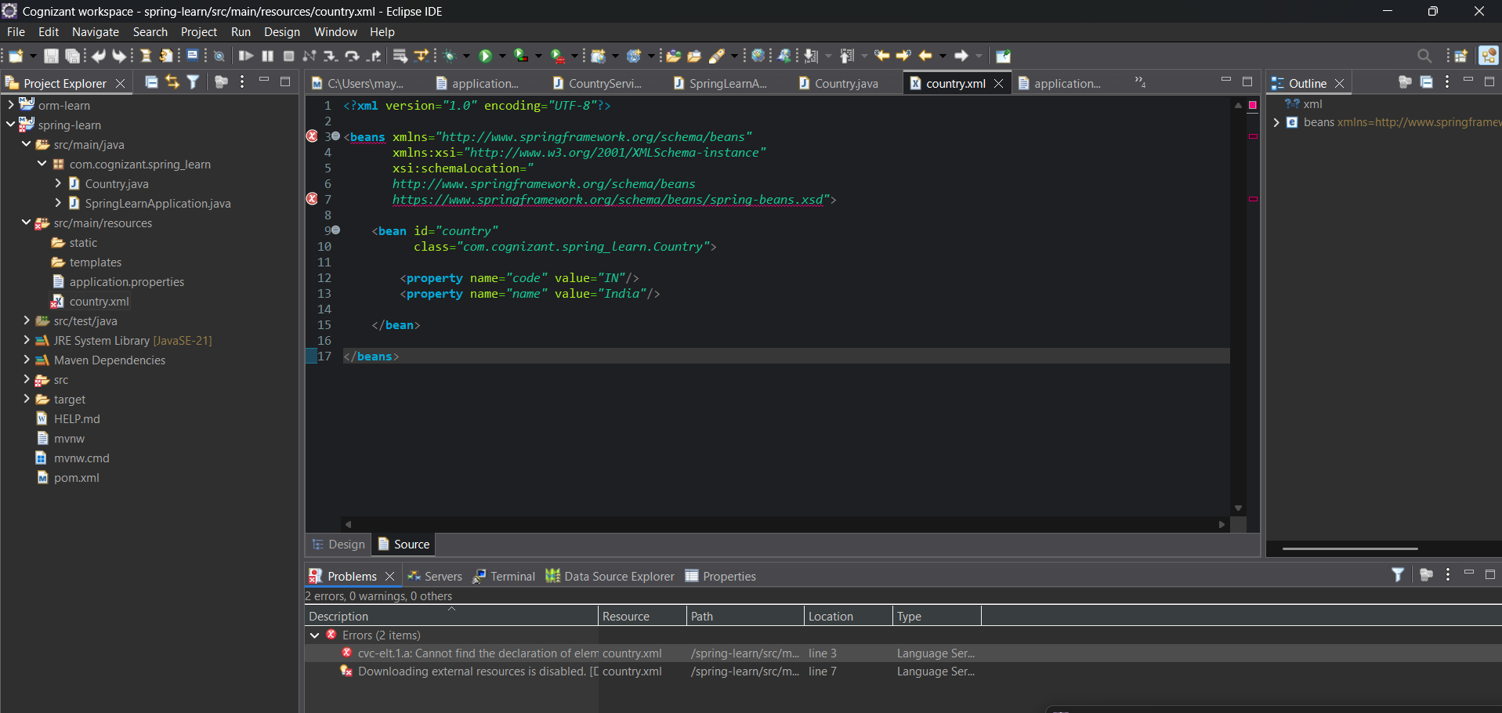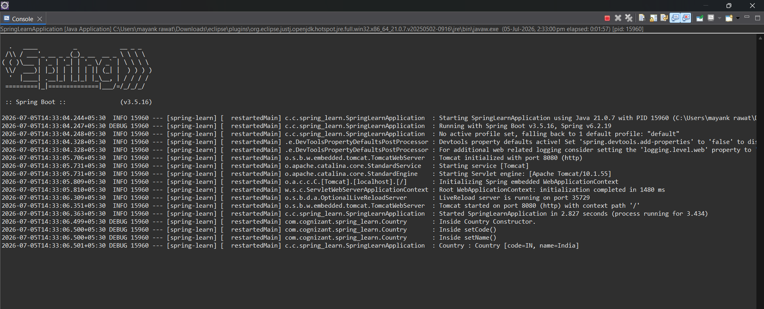

Country.java
package com.cognizant.spring_learn;
import org.slf4j.Logger;
import org.slf4j.LoggerFactory;
public class Country {
private static final Logger LOGGER = LoggerFactory.getLogger(Country.class);
private String code;
private String name;
public Country() {
LOGGER.debug("Inside Country Constructor.");
}
public String getCode() {
LOGGER.debug("Inside getCode()");
return code;
}
public void setCode(String code) {
LOGGER.debug("Inside setCode()");
this.code = code;
}
public String getName() {
LOGGER.debug("Inside getName()");
return name;
}
public void setName(String name) {
LOGGER.debug("Inside setName()");
this.name = name;
}
@Override
public String toString() {
return "Country [code=" + code + ", name=" + name + "]";
}
}

SpringLearnApplication.java
import org.slf4j.Logger;
import org.slf4j.LoggerFactory;
import org.springframework.boot.SpringApplication;
import org.springframework.boot.autoconfigure.SpringBootApplication;
import org.springframework.context.ApplicationContext;
import org.springframework.context.support.ClassPathXmlApplicationContext;
@SpringBootApplication
public class SpringLearnApplication {
private static final Logger LOGGER =
LoggerFactory.getLogger(SpringLearnApplication.class);
public static void main(String[] args) {
SpringApplication.run(SpringLearnApplication.class, args);
displayCountry();
}
public static void displayCountry() {
ApplicationContext context =
new ClassPathXmlApplicationContext("country.xml");
Country country =
context.getBean("country", Country.class);
LOGGER.debug("Country : {}", country.toString());
((ClassPathXmlApplicationContext) context).close();
}
}

Application.properties
spring.application.name=spring-learn
logging.level.com.cognizant.spring_learn=DEBUG

Country.xml
<beans xmlns="http://www.springframework.org/schema/beans"
xmlns:xsi="http://www.w3.org/2001/XMLSchema-instance"
xsi:schemaLocation="
http://www.springframework.org/schema/beans
https://www.springframework.org/schema/beans/spring-beans.xsd">
<bean id="country"
class="com.cognizant.spring_learn.Country">
<property name="code" value="IN"/>
<property name="name" value="India"/>
</bean>
</beans>

